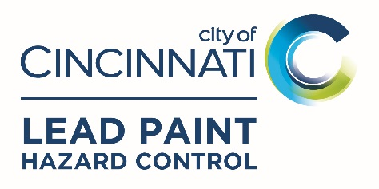
Occupant Information
A separate form is needed for each unit in a multi-family building
One form is required for single-family properties

Home Address
Street Address |  |  | Zip
Apt/Unit # |  |  | Floor
Occupant is: Owner Tenant |  | Information Provided by: Owner Tenant

PRIMARY Occupant Information
Last Name: | First Name:
Primary Phone: | E-mail:
Alternate Phone: | How long have you lived here?
Is English your primary language? YES NO My primary language is: ____________________

Occupant Family Information
How many people live in the home? |  |  |  | Do you receive a Housing Choice Voucher? YES NO
Number living in the home who are:
0 to 5 years old? |  | 6 to 17 years old? |  |  |  | Older than 17 years? |  | Pregnant?
Number of children 0 to 5 years old visiting the home more than 6 hours per week?
Is your home used to care for children under 72 months of age? YES NO

Resident/visiting child information
ALL occupants AND children ≤72 months visiting more than 6 hours a week:
Occupant / Child Visitor  First & Last Name | Birthdate | Resident | Visitor | Has this individual had a blood  lead test? | Approximate date of blood lead test? | Race/  Ethnicity  (Optional to answer)
NOTE: All children less than 6 years old that live in or frequently visit a home accepted into the Lead Hazard Control program are requested to have had their blood tested for lead OR should have a test done within 6 months of a the Lead Hazard Control project being completed.

Occupant INCOME INFORMATION
Provide the following information for all household members over the age of 18 and whether they receive monthly income of any kind (Employer, SSI, Disability, Child Support, Public Assistance, Foster Care, Home Business, etc.). If the individual does not earn income, please list the income as “0”.

Household Member Name | 1. | 2. | 3. | 4.
Employer
Occupation
Race/ Ethnicity (optional to answer)
Age
Monthly Wages | $ | $ | $ | $
Other Monthly Income | $ | $ | $ | $
Source(s) of Monthly Income
TOTAL MONTHLY INCOME | $ | $ | $ | $
If no one in your household is receiving any income, please indicate how the household is currently supporting itself financially:

INCOME SIGNATURE
I certify under penalty of law that the information contained in this declaration is true, accurate and complete to the best of my knowledge. I agree to provide, upon request, documentation on all income sources to the Intake Coordinator. The information provided above is subject to verification by the United States Department of Housing and Urban Development at any time, and Title 18, Section 1001 of the U.S. Code states that a person is guilty of a felony and assistance can be terminated for knowingly and willingly making a false or fraudulent statement to a department of the Unites States Government.
Print Name |  | Owner | Tenant
Signature |  | Date
Submit completed Occupant Information form to your property owner, or directly to:

LEAD PAINT HAZARD CONTROL PROGRAM
Attn: Intake Coordinator
805 Central Avenue Suite 700
Cincinnati, Ohio 45202

